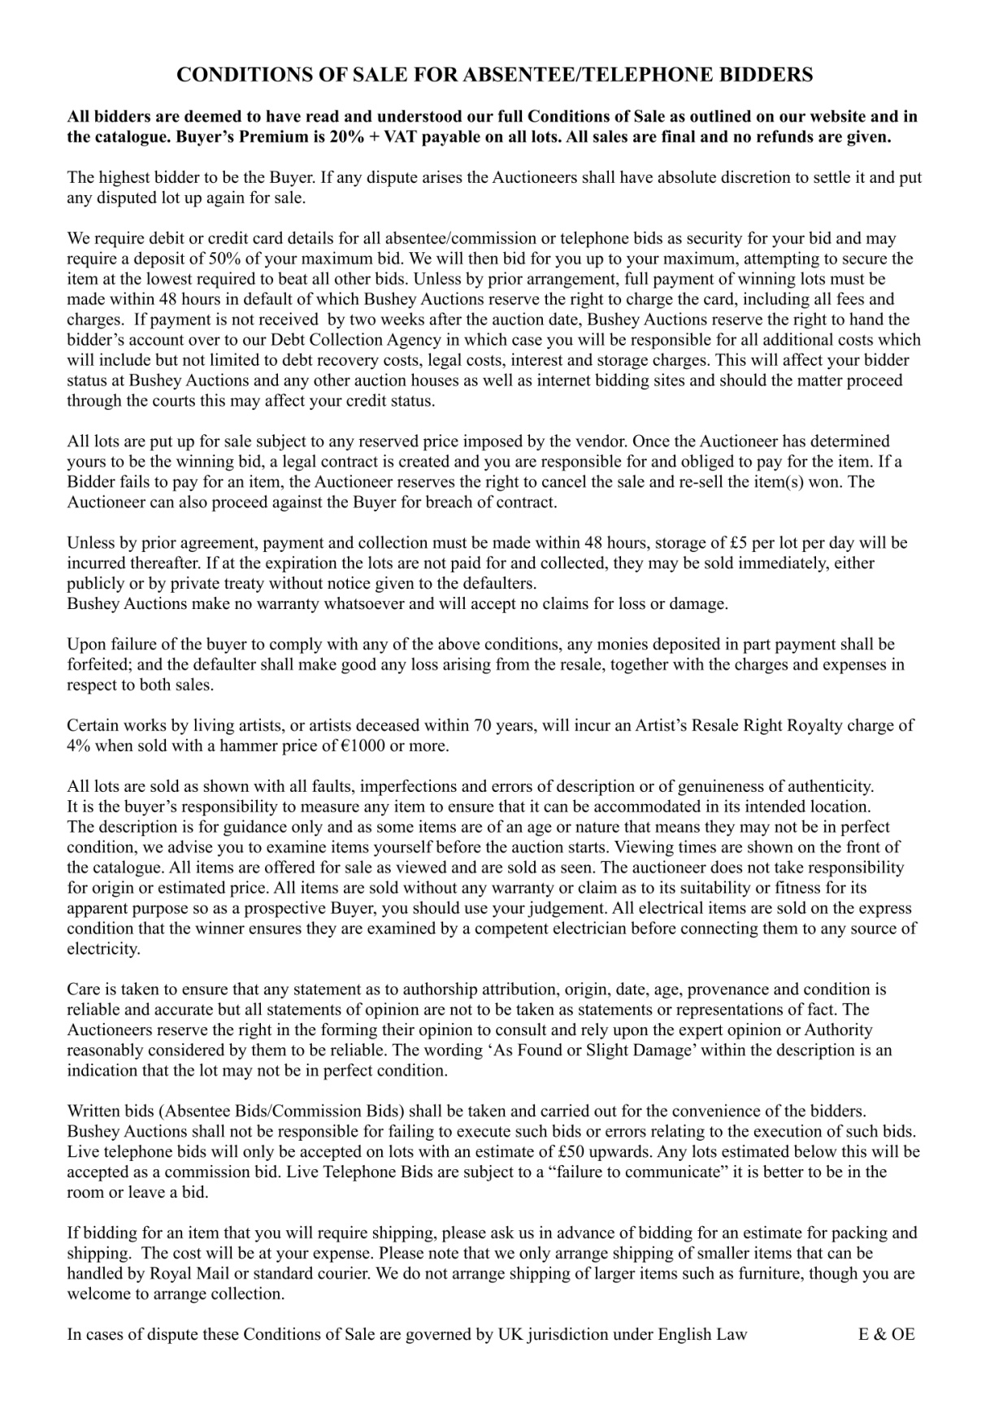
TELEPHONE
BIDDING FORM
Tel: 020 8386 2552/07504 201202
Email: enquiries@busheyauctions.com

PLEASE COMPLETE CLEARLY IN BLOCK CAPITALS
Name

Address

 | Post Code
Tel No. | Fax No.
Mobile No. | Email
Debit/Credit card no. | Expiry date | CSC No. (last 3 digits)

Lot No. | Description
Payment and collection must be made within 48 hours. Storage of £5 per lot per day will be included thereafter
I agree to comply with the Terms and Conditions of sale
Buyers premium is 20% + VAT (24%)
Signed : Date:
Office use only:
Auction Date | Buyer Number

